Self-introduction of Du Xinyu

CST 190131

Xiamen University Malaysia

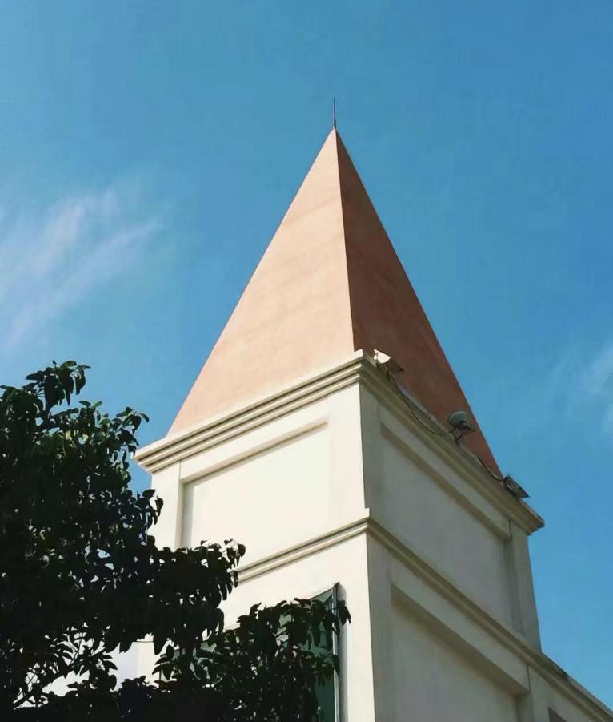

Basic information about me

Name : Du Xinyu

Native place : Fu Jian

Nationality : China

Major : Computer science and technology



My hometown

My education experience

Primary school: Xiamen music school

Junior high school: Xiamen music school

High school: Xiamen No.2 middle school

University: XMUM

My junior high school